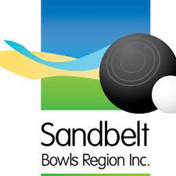
Sandbelt Regional Sides
Expression of Interest Form 2023/2024
(Men’s Team/Women’s Team)

Event date/location: January 13th-14th 2024 (Ballarat VIC)

Trial dates/locations: November 5th (Royal Melbourne BC) AM-Women’s Trials
PM-Men’s Trials

NOTE: To be eligible to play for the Sandbelt region for the 2024 Region Sides Championships, applicants must be a full playing member with a club in the Sandbelt Region, as of January 1st/2024.

Completed forms to be emailed to the Sandbelt Selection Committee: sandbeltselection@gmail.com and must be received no later than Octobre 31st/2023.

Only successful applicants (maximum/top 24) will be invited to a regional trial.
From there a team of 12 players + 1 Travelling Reserve + 1 Non-Travelling Reserve will be named, along with a non-playing manager.

Please ensure your contact details above are correct to receive future communication.
Thank you for your interest and good bowling!

Player’s Details:

Name: _____________________________________________________________________
Email Address: _______________________________________________________________
Phone Number: ______________________________________________________________
CLUB: ______________________________________________________________________
DIVISION: ___________________________________________________________________
POSITION: __________________________________________________________________

Results (past 2 years)  -Club (Championships & Pennant)  -Regional Events  -State Events  -National Events  (ex: Australian Indoors/Sides/Australian Championships)  -International  -Other (Tournament etc) | 2022/2023 Season
 | 2021/2022 Season

Please list any other notable results you would like us to know about:

In 2-3 sentences, tell us why you would like to take part in Region Sides and why you believe you would be an asset to the team:

